Demo Day Proposal

**Machine Learning with TensorFlow Training**

**Professional Academy Digital Talent Scholarship 2022**

|  |  |
| --- | --- |
| **Group Number** | **FIN_7** |
| **Dataset** | Fintech/Banking and Finance |
| **Name - DTS ID** | 1. **Viola Fabianto - 152236035101-404** 2. **Muh. Chaerul, S.Si - 152236035101-128** 3. **Godfried Junio Sebastian Matahelemual - 152236035101-175** 4. **Hartmann Hardyanto Ngono - 152236035100-603** 5. **Yanuar Bhakti Wira Tama - 152236035101-303** |

Selected Theme: Prediction Model for Banking Sector

**Project Title:**

Prediction Model for Direct Marketing Campaign Conversion on Term Deposit Product in Banking Sector

**Executive Summary:**

Deskripsi singkat (~500 karakter/100 kata) dari proyek Anda mencakup **Pernyataan Masalah, Pertanyaan Penelitian, Latar belakang masalah, dan alasan mengapa tim Anda ingin mengatasi masalah tersebut.**

**Problem Statement:**

Recent studies suggest that as of June 2020, companies and organizations within the banking and financial sector are spending an average of 13% of their overall budget on marketing [1]. One of alternative in marketing is telemarketing or direct marketing by telephone. Telemarketing can be an effective method for reaching your customers. The telephone can be used to contact new customers, to maintain contact with current customers and to remind slow payers personally. One advantage to telemarketing is that you will get an instant response [2].

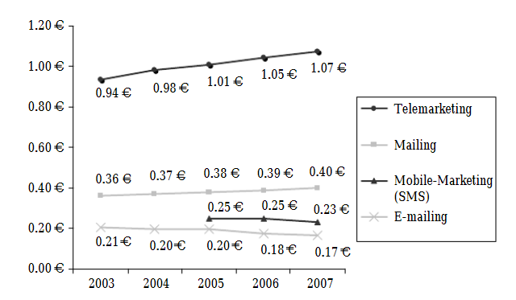

Figure 1-1. Unit Cost Per Contact and Media (2003-2007)

(taken from [2])

However, as seen at Figure 1-1, cost per contact for telemarketing has rising up from 2003 to 2007 and expected to be much higher now at 2022. Therefore, to maximize profitability, we need to reduce these marketing cost or increase the effectiveness of the cost with higher conversion.

**Proposed Solution:**

To be cost effective, companies must target their marketing plan [3]. It is more cost effective for companies to spend resource on customers which more likely to convert or subscribe to their products. We will develop a model based on historical marketing campaign efforts and results to predict with high accuracy whether a potential customer will subscribe to our products upon contact. Using this model, companies can save resources on marketing cost by focusing marketing efforts on customers which yield positive result.

**Project Scope & Deliverables:**

Garis besar batasan proyek dan deskripsi tentang bagaimana tim Anda akan memecah tugas menjadi hasil yang terukur. Cakupan terperinci (harian) lebih disukai. Tapi mingguan juga bisa diterima. Harap diperhatikan bahwa Anda memiliki waktu satu bulan untuk menyelesaikan proyek ini.

|  |  |
| --- | --- |
| Scope Description | Develop a model capable of predicting the success of direct marketing campaign conversion for term deposit product in banking sector based on age, job/employment, marital status, educational background, credit history, existing loan, and previous campaign history. |
| Project Deliverables | * a prediction model (.ipynb) * a well-defined documentation describing work process and parameter tuning |
| Acceptance Criteria | * prediction model has minimum accuracy of 92% in testing phase * <insert more model score requirements> |
| Constraints | * Since train dataset was made using Portuguese banking data, dataset for prediction requires all monetary values to be stated in Euros (€) |
| Assumptions | * The customer didn’t receive any contacts through other means beside phone calls |

**Project Schedule**

Tampilan tugas dan pencapaian proyek tingkat tinggi (grafik Gantt berguna untuk ini). Pastikan bahwa tonggak sudah disepakati di antara rekan tim Anda. Jangan lupa untuk melaporkan apa yang dilakukan oleh semua anggota kelompok.

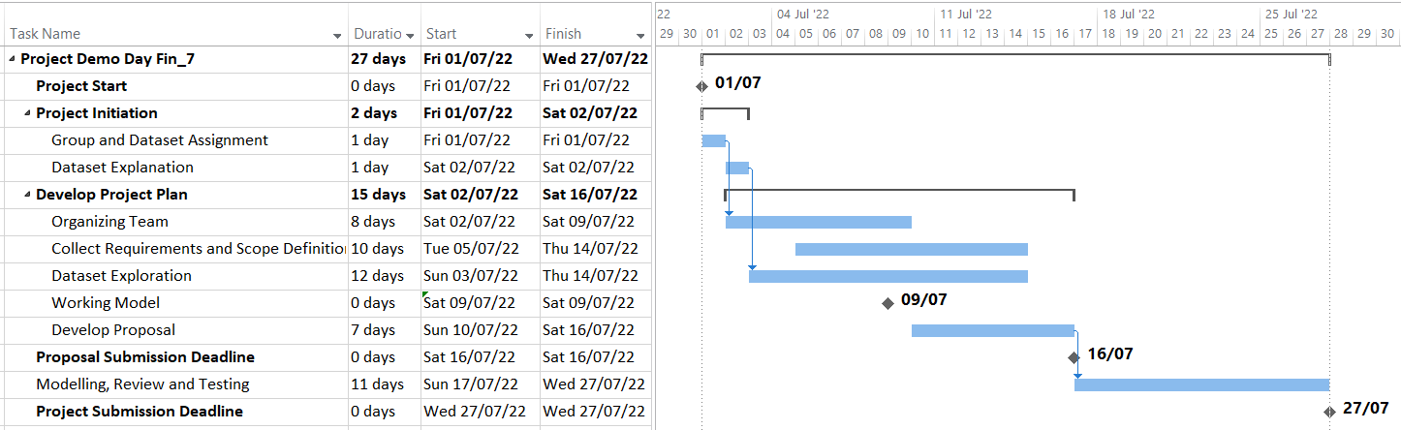

**Risk and Issue Management Plan**

Daftar faktor yang dapat menggagalkan proyek dan rencana bagaimana masalah akan diidentifikasi, ditangani, dan dikendalikan. Dipersilakan jika peserta memiliki rencana B untuk permasalahan atau ancaman tersebut.

List of threat factors that endangers project:

Risk and Issue Management Process

The following illustrates the risk and issue management process for this project.

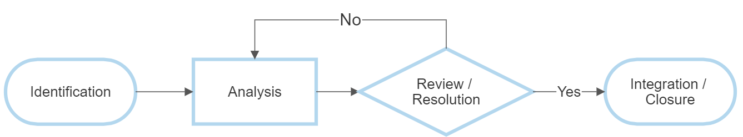

Figure 1-1. Risk and Issue Management Process Flow

Identification

At any time during the project, a project team member can initiate a risk or issue by providing the project team with the following:

1. Title
2. Category
3. Description

A project team member will log the risk into the Risk, Action, Issues, Decisions (RAID) Log. The project team will review the item, set the Risk Probability or Issue Priority and make sure it is valid and clear.

Analysis

If the item is valid, the project team will explore alternatives and develop the recommended risk strategy, response plan, and identify the risk triggers, or develop the issue resolution recommendation.

Review / Resolution

Risks and issues will be reviewed during the project team meeting. Risks and issues will only be closed by consensus of the team. If there is no impact to the project scope, schedule or budget, the project team can decide to accept the response plan / resolution recommendation. A project team will record whether the risk response plan / issue resolution recommendation is approved in the RAID Log. If the recommended risk response plan / resolution is not approved by consensus of the project team, the risk will be returned to the Analysis stage.

Integration / Closure

A project team member will update the necessary project control documents when a risk response plan or issue resolution is approved, if appropriate. One or more of the following may be needed:

* Include new tasks required to implement the response plan in the project schedule.
* Update the scope statement in the project scope if needed.

Once a risk trigger is realized, it becomes an issue and is closed and follows the issue management process.

Project RAID Log

All project risks and issues will be tracked in the RAID Log.

The following information will be captured as needed in the issues log:

* Date submitted/identified.
* Issue category (e.g., budget, requirements, resources, schedule, scope).
* Issue title.
* Description.
* Resolution.
* Other issues that are related to the issue.

Additional documentation may be attached as needed.

The following information will be captured as needed in the risk log:

| **Field** | **Definition** |
| --- | --- |
| **Number** | Sequential |
| **Title** | Brief description |
| **Category** | E.g., budget, implementation, quality, resources, schedule, scope |
| **Description** | Longer description of the risk |
| **Risk Impact** | E.g., budget, implementation, quality, resources, schedule, scope |
| **Consequence** | Description of consequence to project if risk is realized |
| **Risk Strategy** | Avoid, Transfer, Mitigate, Accept |
| **Planned Response** | Description of how to respond to the risk. |
| **Risk Trigger** | Description of how to identify if the risk is occurring or becomes an issue |

**Project Reference**

Dataset apa saja yang digunakan, makalah/jurnal/artikel, dan sumber daya lain yang diperlukan untuk memenuhi tujuan proyek.

[Dataset]

[Moro et al., 2011] S. Moro, R. Laureano and P. Cortez. Using Data Mining for Bank Direct Marketing: An Application of the CRISP-DM Methodology.

In P. Novais et al. (Eds.), Proceedings of the European Simulation and Modelling Conference - ESM'2011, pp. 117-121, Guimarães, Portugal, October, 2011. EUROSIS.

[1] ActiveWin.co.uk (2020). How Much Do Banks Spend on Marketing?. November 6th,2020.  
(taken at July 9th, 2022 at https://www.activewin.co.uk/blog/how-much-do-banks-spend-on-marketing )

[2] Reinares, Pedro & Casado, José Manuel. (2008). Evaluation of cost per contact and cost per response in interactive and direct media planning: A Spanish case study. Direct Marketing: An International Journal. 2. 159-173. 10.1108/17505930810899311.

[3] Vachowiak, Connie L. (2006). Cost/Benefit Analysis of Marketing Efforts In A Bank. University of Wisconsin-Stout, December 2006.  
[taken at July 9th, 2022 at https://citeseerx.ist.psu.edu/viewdoc/download?doi=10.1.1.390.3273&rep=rep1&  
type=pdf]